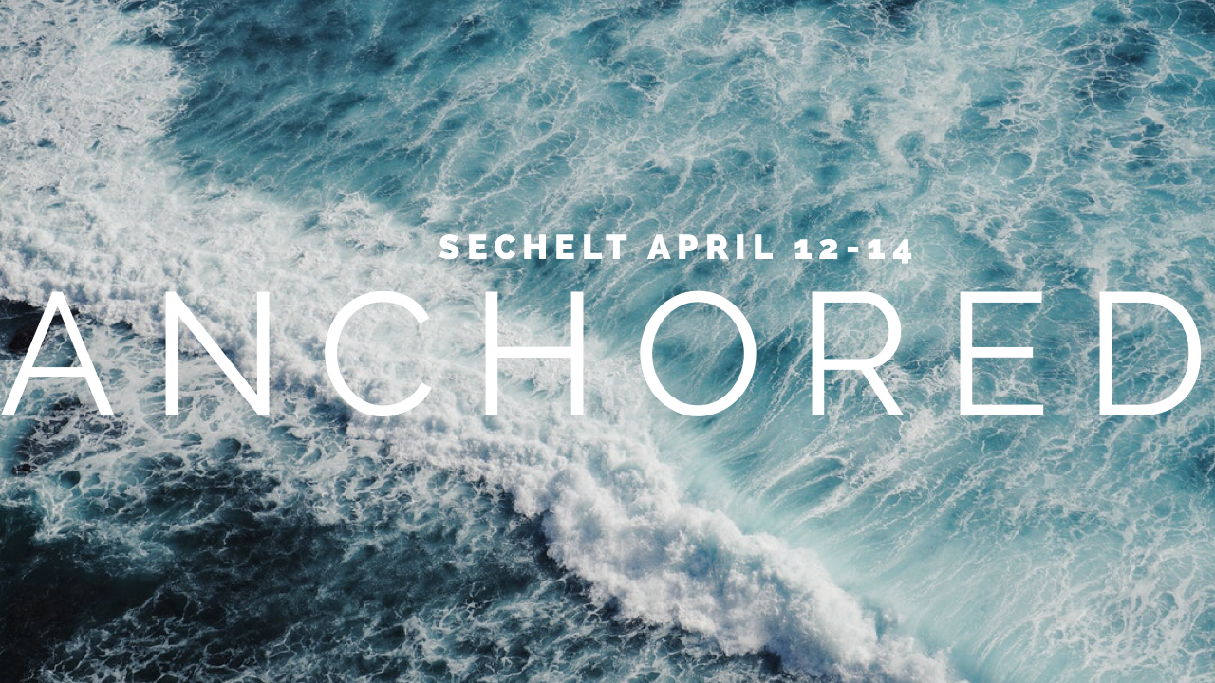An opportunity to cross land and sea and step away from the business to enjoy good food, good people, and God. We will be joined by the youth from Eagle Ridge Bible Fellowship and Blue Mountain Baptist. Our retreat will be at Camp Douglas. We will car pool to Horseshoe Bay on Friday April 12 and pickup will be from the Horseshoe Bay Terminal early afternoon on Sunday April 14.
Cost: $100 (Includes ferry, food, and accommodations)
Also we are looking for some cooks to come along!
Anchored Retreat Packing List (1 bag limit)

-Sleeping Bag
-Pillow
-Toothbrush
-Toothpaste
-Pyjamas (Onesies are encouraged)
-2 days’ worth of warm clothes
-Shoes that can get dirty
-Jacket
-Rain gear; umbrella, water-repellant jacket
-Toiletries
-Soap/Shampoo
-Towel
-Swimsuit**
-Deodorant (don’t miss this one, please)
-Bible
-Notebook
-Pen/Pencil
-Flashlight
-Medicine (if you need it)

Release Form

For insurance reasons ALL persons must fill out the following form and sign prior to leaving for camp. Anyone under the age of 18 must have a parent sign and complete this form.

Name of Youth Participant:_______________________________________

Address:_____________________________________________________

Phone: _______________________________________________________

Any Health Related Concerns (that should be disclosed?):
_____________________________________________________________
_____________________________________________________________

Dietary Restrictions:

Traveling with: Calvary Baptist Church
1636 Regan Ave
Coquitlam, BC, V3J 3B8
(604) 936-8242

Destination: Camp Douglas
1341 Margaret Rd,
Roberts Creek,
BC V0N 2W2
(604) 885-3355

I, ___________________ give my son/daughter, _____________________, permission to attend BMBC’s Anchored Retreat at Camp Douglas from April 12-14, 2019. I grant permission for him/her to travel with the leaders and youth from Blue Mountain Baptist Church, Calvary Baptist Church and Eagle Ridge Bible Fellowship.

_______________________ _____________________________
Date Signature of Parent/Guardian

